Mohamed Abdelsalam Abdelsattar Mohamed   
  
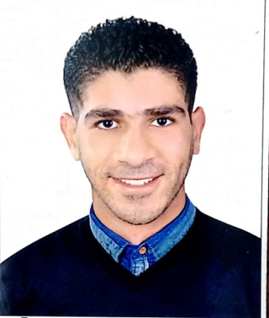  
  
  
Contact address

**Egypt /ismailia / ard elgamiat block 64 hom 17**

**Mobile:** **+0201205597092**   
 **E-mail:Mobeso89@gmail.com**

Personal details: **Date of Birth: 22/12/1989**

**Nationality: Egyption**

Marital status:Exempted

status:**Single**  
Education: **Bachelor of tourism and hotels (2011)**

**Work Experience**

**1-jushi Egypt company for fiber glass**

**Operation department (team leader) from 2013 to 2014**

**Training jushi china for 3 month**  **(Operation – Management ) 2- Americana bahrain from 2014 to 2015**

**Operation department  
(Assistant Restaurant Manger k.f.c) **

**-Training in Americana Bahrain k.f.c**

**( Operation – Management )**

**(coaching&MENTORING)**

**( Get Ready to lead )  
  
  
3-ELSANIDI for trading and Contracting**

**Store Administrator from 2016 to 2017** 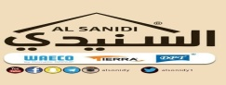

**Skill**

**Language :** • **Arabic** fluent)

• **English ( Good )**

• **Typing an Computer**

• **Supportive – Welcoming – Friendly – caring – Activity – diplomatic – hard worker**

• **Fast learner -work under pressure**